LIBRARY MANAGEMENT SYSTEM:

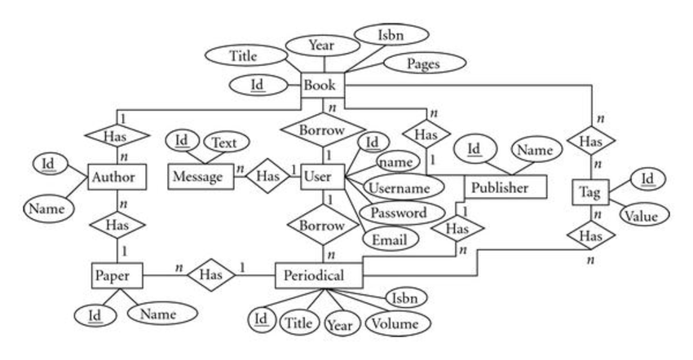

CREDIT CARD SYSTEM:

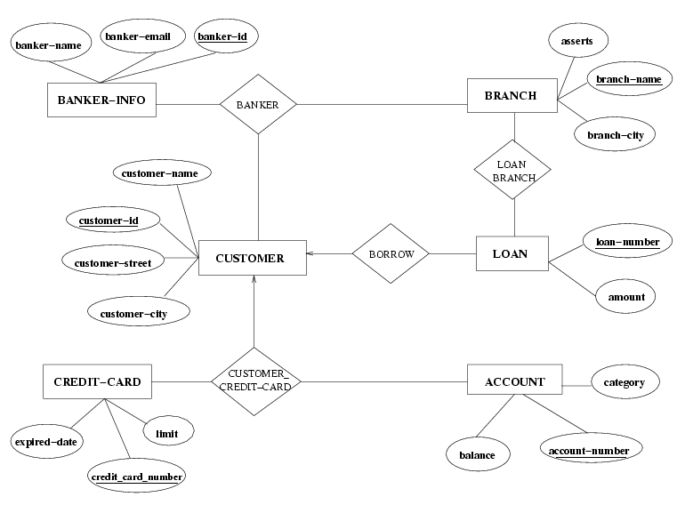

ONLINE SHOPPING SYSTEM:

